Unit 1: Basic Economic Concepts

Scarcity, choice, and opportunity costs

Difficulty Level 1
- The problem of “scarcity” exists in economics because:
  - people have limited needs
  - people have limited wants
  - all markets have shortages
  - there are limited resources to fulfill unlimited wants
  - there are unlimited resources and limited demand
- The basic economic problem of all countries is the existence of
  - shortages of goods and services during recessions
  - unlimited wants and scarce resources
  - wage increases and high production costs
  - unemployment and inflation
  - rising budget deficits
- The critical problem of economics is:
  - creating laws to protect resources from overuse
  - allocating scarce resources to satisfy wants
  - providing citizens with welfare and social services
  - developing a monetary system
  - establishing a system of fair taxation
- When one decision is made, there are alternatives that are not chosen. The next best alternative not selected is called
  - opportunity cost
  - scarcity
  - comparative advantage
  - absolute disadvantage
  - production possibility
- Jiang prefers bicycling to running and he prefers running to swimming. If these are his only three choices, what is his opportunity cost of bicycling?
  - bicycling
  - running and swimming
  - running
  - swimming
  - the price of the bicycle
- Which of the following is an example of a resource?
- wheat
- an oven
- a pizza
  - I only
  - II only
  - III only
  - I and II only
  - I, II, and III
- A truck driver receives safety training. What kind of resource has the truck driver acquired?
  - labor
  - human capital
  - physical capital
  - entrepreneurship
  - land

Difficulty Level 2
- Which of the following situations represent scarcity?
- Air pollution in a growing economy.
- Floppy disks are no longer being produced.
- There is a finite amount of coal in the physical environment.
  - I only
  - II only
  - III only
  - I and III only
  - I, II, and III
- Microsoft finds it difficult to hire enough skilled computer programmers. This statement represents the concept of:
  - scarce resources are not that costly
  - resources are scarce
  - unlimited supply of resources
  - fixed prices of labor
  - physical capital
- The school cafeteria has pizza, chicken, or cheeseburgers for lunch. You decide to have chicken but if they were out of chicken you would have chosen pizza. The opportunity cost of choosing chicken is:
  - pizza
  - chicken
  - a cheeseburger
  - pizza and a cheeseburger
  - pizza, chicken, and a cheeseburger
- If the supply of all resources were unlimited then:
  - needs and wants would be limited
  - technological research would no longer be necessary
  - goods and services would be distributed equally
  - the concept of opportunity cost would no longer be relevant
  - nominal wages would decrease

Production possibilities curve

Difficulty Level 1
- Suppose the nation of Econoland decides to produce only books and records. According to the production possibilities curve, as book production increases, the production of records will:
  - not change
  - increase
  - increase at an increasing rate
  - increase at a decreasing rate
  - decrease

Difficulty Level 2
- What conditions exist if an economy is producing a level of output that is on its production possibilities curve?
  - idle resources
  - equitable distribution of goods and services
  - inefficient use of resources
  - no idle resources and efficient use of resources
  - inflation and high unemployment
- A point inside the production possibilities curve represents:
  - efficient production
  - inefficient production
  - an increase in production possibilities
  - economic growth
  - inflation
- The production possibilities curve will shift outward for which of the following reasons?
- The unemployment rate decreases.
- There is a significant natural disaster.
- A new technology improves worker productivity.
  - I only
  - II only
  - III only
  - I and III only
  - I, II, and III
The following three questions refer to the following graph of a country’s production possibilities curve.
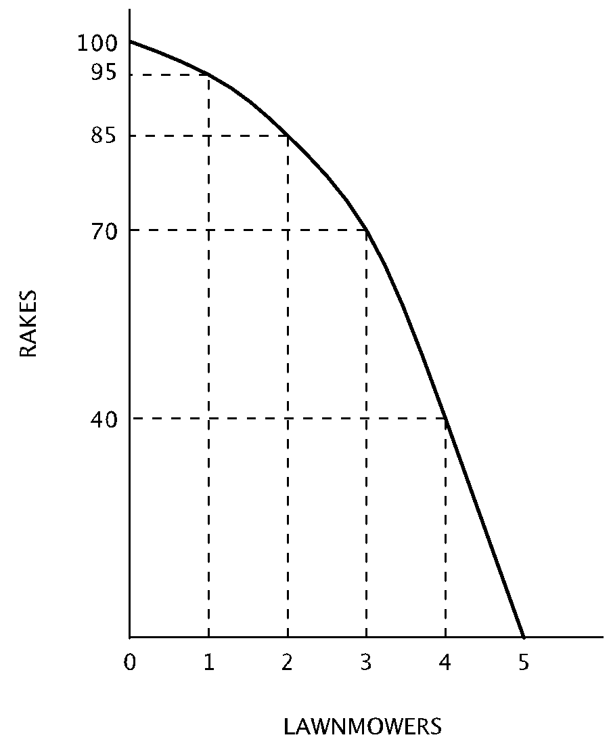
- If one lawnmower is currently being produced, the opportunity cost of producing the second lawnmower is:
  - 100 rakes
  - 95 rakes
  - 85 rakes
  - 15 rakes
  - 10 rakes
- Which of the following combinations of rakes and lawnmowers represents an inefficient level of production?
  - 100 rakes and 5 lawnmowers
  - 95 rakes and 1 lawnmower
  - 85 rakes and 2 lawnmowers
  - 70 rakes and 2 lawnmowers
  - 40 rakes and 4 lawnmowers
- The best combination of rakes and lawnmowers for this economy to produce is
  - 100 rakes and 0 lawnmowers
  - 0 rakes and 5 lawnmowers
  - 70 rakes and 3 lawnmowers
  - 40 rakes and 4 lawnmowers
  - indeterminate with the available information

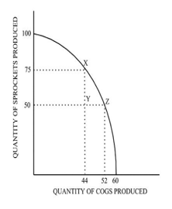
- On the basis of the diagram above showing an economy’s production possibilities curve for two goods, which of the following statements is true?
- The opportunity cost of moving from point X to point Z is 25 sprockets.
- The opportunity cost of moving from point Z to point X is 8 cogs.
- The opportunity cost of moving from point Y to point X is 0 cogs.
  - I only
  - II only
  - I and II only
  - II and III only
  - I, II, and III
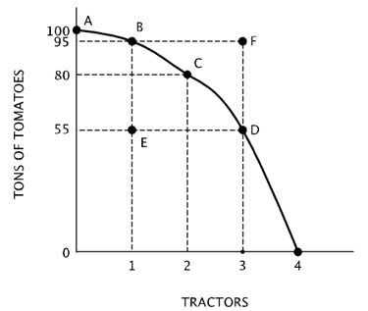
- On the basis of the diagram above showing an economy’s production possibilities curve for two goods, what does Point F represent?
  - A level of production that is efficient.
  - The best level of production.
  - A level of production that is attainable, but not efficient
  - A level of production that is unattainable with current resources
  - A level of production that can be attained by producing fewer tractors
- On the basis of the diagram above showing an economy’s production possibilities curve for two goods, what does Point E represent?
  - A level of production that is efficient
  - The best level of production
  - A level of production that is attainable, but not efficient
  - A level of production that is untattainable with current resources
  - A level of production that can only be attained with economic growth
- Based on the diagram above, suppose the economy is now producing two tractors. What is the opportunity cost of producing a third tractor?
  - 5 tons of tomatoes
  - 15 tons of tomatoes
  - 25 tons of tomatoes
  - 55 tons of tomatoes
  - 80 tons of tomatoes

Difficulty Level 3
- An economy can be using resources more efficiently when:
  - it can increase its opportunity costs
  - it can distribute goods and services equitably
  - it can reduce poverty
  - it can make industrial production more profitable
  - it can make some people better off without making others worse off

Comparative advantage, absolute advantage, specialization and exchange

Difficulty Level 1
- An economy is said to have an absolute advantage in the production of a good if it can:
  - produce that good at a lower opportunity cost than another economy
  - produce that good at a higher opportunity cost than another economy
  - produce that good at an equal opportunity cost than another economy
  - produce a higher quantity of that good than another economy
  - produce a lower quantity of that good than another economy

Difficulty Level 2
- An economy is said to have a comparative advantage in the production of a good if it can:
  - produce that good at a lower opportunity cost than another economy
  - produce that good at a higher opportunity cost than another economy
  - produce that good at an equal opportunity cost than another economy
  - produce a higher quantity of that good than another economy
  - produce a lower quantity of that good than another economy
Use the table below to answer the following questions.
 | Cell Phones | Televisions
Northland | 40 | 20
Southland | 10 | 10
- What is the domestic opportunity cost of producing 1 cell phone in Northland and Southland, before specialization and trade?
Northland Southland
  - 0.5 televisions 1 television
  - 1 television 1.5 televisions
  - 0.5 televisions 0.5 televisions
  - 2 televisions 1 television
  - 1.5 televisions 2 televisions
- What is the domestic opportunity cost of producing 1 television in Northland and Southland, before specialization and trade?
Northland Southland
  - 0.5 cell phones 1 cell phone
  - 1 cell phone 1.5 cell phones
  - 2 cell phones 0.5 cell phones
  - 2 cell phones 1 cell phone
  - 1.5 cell phones 2 cell phones
Use the graph below to answer the following questions.
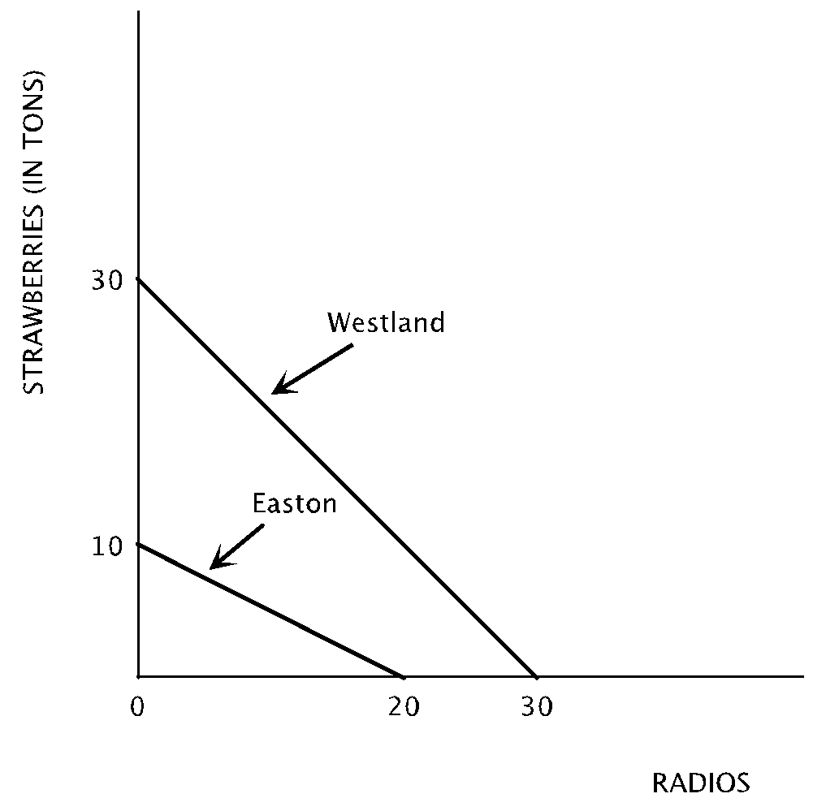
- What is the domestic opportunity cost of producing 1 strawberry in Easton and Westland, before specialization and trade?
Easton Westland
  - 0.5 radios 1 radio
  - 2 radios 1 radio
  - 0.5 radios 0.5 radios
  - 1 radios 1 radio
  - 1.5 radios 2 radio
- According to the diagram, which of the following statements is true?
  - Easton has an absolute advantage in radio production, Westland has an absolute advantage in strawberry production.
  - Westland has an absolute advantage in the production of both goods, Easton has a comparative advantage in strawberry production.
  - Westland has an absolute advantage in the production of both goods, Easton has a comparative advantage in radio production.
  - Westland has an absolute advantage in the production of both goods, Easton has a comparative advantage in the production of both goods.
  - Neither country can benefit from trade
- Under what terms of trade would both Easton and Westland find it mutually beneficial to specialize and trade?
  - 1 ton of strawberries = 3 radios
  - 1 ton of strawberries = 1.5 radios
  - 1 ton of strawberries = 1 radio
  - 1 ton of strawberries = 0.5 radios
  - There are no terms of trade that would enable both countries to benefit because Westland has an absolute advantage in both goods
The following questions are based on the table below, which indicates labor-hours needed to produce a single unit of each of two goods in each of two nations.
 | Lobster | Bananas
Nation A | 10 labor-hours | 20 labor-hours
Nation B | 15 labor-hours | 45 labor-hours
- If labor is the only factor used to produce the goods, in each nation, what is the opportunity cost of producing one unit of lobster?
Nation A Nation B
  - 0.5 bananas 0.33 bananas
  - 1 banana 0.5 bananas
  - 0.5 bananas 3 bananas
  - 1 banana 1.5 bananas
  - 2 bananas 3 bananas
- The table above indicates labor-hours needed to produce a single unit of each of two goods in each of two nations. If labor is the only factor used to produce the goods, which of the following statements must be correct?
- Nation A has an absolute advantage in the production of both goods, but a comparative advantage in the production of bananas.
- Nation B has an absolute advantage in the production of both goods, but a comparative advantage in the production of lobster.
- Mutually advantageous trade can occur between the two nations when 2.5 units of lobster are exchanged for 1 unit of bananas.
  - I only
  - II only
  - III only
  - I and III only
  - II and III only

Difficulty Level 3
- If Northland and Southland were to specialize and trade, Northland would find it advantageous to:
  - export televisions and import cell phones
  - export cell phones and import televisions
  - export both cellphones and televisions and import nothing
  - import both cellphones and televisions and export nothing
  - trade 3 cell phones for 1 television

Comparative Advantage
1 | D
2 | A
3 | A
4 | D
5 | B
6 | C
7 | B
8 | A
9 | D
10 | B

Answers:
Scarcity, Choice, OC
1 | D
2 | B
3 | B
4 | A
5 | C
6 | D
7 | B
8 | D
9 | B
10 | A
11 | D
The PPC
1 | E
2 | D
3 | B
4 | C
5 | E
6 | D
7 | E
8 | E
9 | D
10 | C
11 | C
12 | E

